RECRUITING ASSISTANT FOR HR MANAGER



Project Report

1. **INTRODUCTION**

**1.1 OVERVIEW**

Human resource management (HRM or HR) is the strategic and coherent approach to the effective and efficient management of people in a company or organization such that they help their business gain a competitive advantage. It is designed to maximize employee performance in service of an employer's strategic objectives.

In an organization, employees are the ones who are responsible for carrying out work activities involved in operational process. It is the key job of managers and HR professionals to organize the employees in order to bring effectiveness in their performances. This can be done only if the employees are viewed as invaluable assets and not just machines. Considering employees as assets is an integral part of modern HRM and human capital Management.

Human resource management plays very significant role in ensuring the success of the organization and also helps to improve its brand image which in turn helps the company or the organization to sustain in the market for long. The following will help to provide a brief idea regarding the concepts of human resource management as well as management with respect to different organization. These further deals with the case scenario provided and the organization related to the same one of the organization provide being the Chicken.

Master. The given organization has been compared to the popular organization Google, in order to get an idea about the recruitment and the selection policies of the same.

Core HR provides software features for overseeing the operations HR departments traditionally managed. These functions include personnel tracking, payroll processing and benefits administration.

Owners or managers of small companies often handle HR functions personally. But as your small business grows, it becomes more likely that other important responsibilities will suffer as the tasks pile up. There comes a point where you can only juggle so many hats.

How can you know when it’s time for core HR features? If your business has become too large to handle the staff’s payroll and oversee the day-to-day administrative tasks, it’s probably time for an upgrade.

In some cases, businesses don’t have any dedicated system in place. Yes, they probably have software for running payroll — and possibly a spreadsheet for tracking employee info — but that may be the extent of their HR software.

On the flip side, you might have an HRIS that you’ve outgrown. It was great when there were only 20 employees to manage, but now that you’ve reached 70, the software doesn’t have nearly enough functionality.

No matter your situation, we recommend building a list of requirements to help pinpoint the key capabilities you should look for.

1.2 PURPOSE

The purpose of HRM is to maximize the productivity of an organization by optimizing the effectiveness of its employees. This mandate is unlikely to change in any fundamental way, despite the ever-increasing pace of change in the business world.

Within the unit of each organization, the objectives of HRM are to: Help the organization achieve its goals by providing and maintaining productive employees. Efficiently make use of the skills and abilities of each employee. Make sure employees have or receive the proper training.

One of the primary goals of the HR department is to maintain productivity providing the company with an adequate number of skilled and efficient workers. A good HR manager should continually analyze the workload and know where there are potential problems with manpower and when it's time for additional help.

* : Show employees that their feedback matters. ...
* Recognize to empower. ...
* Provide opportunities for professional growth — and the necessary support
* Make empowerment part of your organization's culture and vision.

2. PROBLEM DEFINITION AND DESIGN THINKING

2.1 EMPATHY MAP:

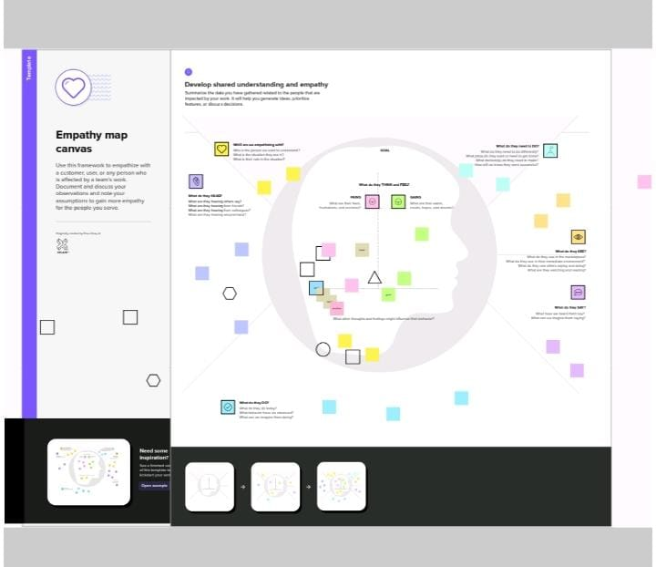

2.2 IDEATION AND BRAINSTROMING MAP

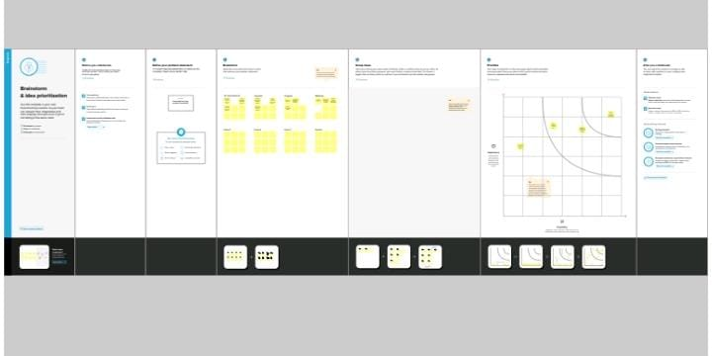

3. RESULT:

3.1 DATA MODEL

|  |  |  |  |  |  |  |  |
| --- | --- | --- | --- | --- | --- | --- | --- |
| **Object name** |  | | **Fields in the Object** | | | | |
| object1 |  | |  | | | | |
|  | Field label | |  | Data type |  | | |
| Custom object | |  | Auto number ,Text |
| Tab | |  | Real Estate, tab style |
|  | |  |  |
| object2 |  |  | |  |  |
| Field label | |  | Data type |  | | |
| Field | |  | URL |
| Junction object | |  | Auto Number, Mater devil |
|  | |  | |
| Object3 |  | Page layout | |  | Status, technical side | |
| Validation rules | |  | Checkbox Not equal and equal | |
| profile | |  | Test stnd user , Seles profile | |
| user | |  | Sanjay gupta, Abhilash garapati | |
| Permission set | |  | Review object | |
| report | |  | Account, review , job posting object | |

3.2 ACTIVITY AND SCREENSHOTS

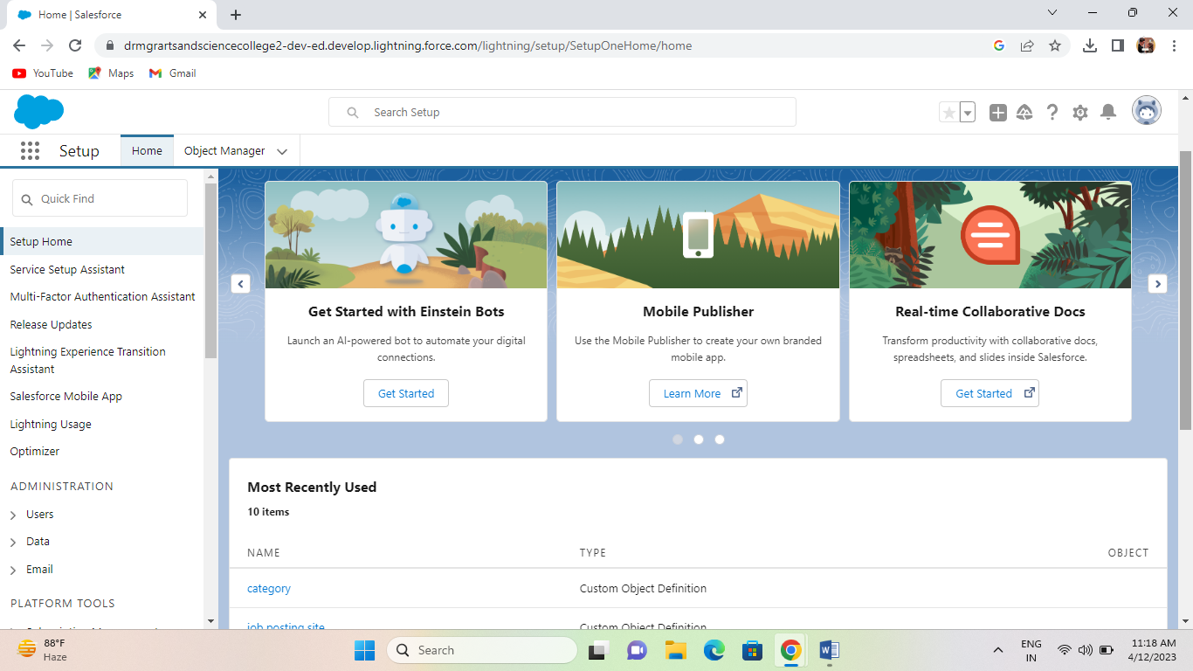

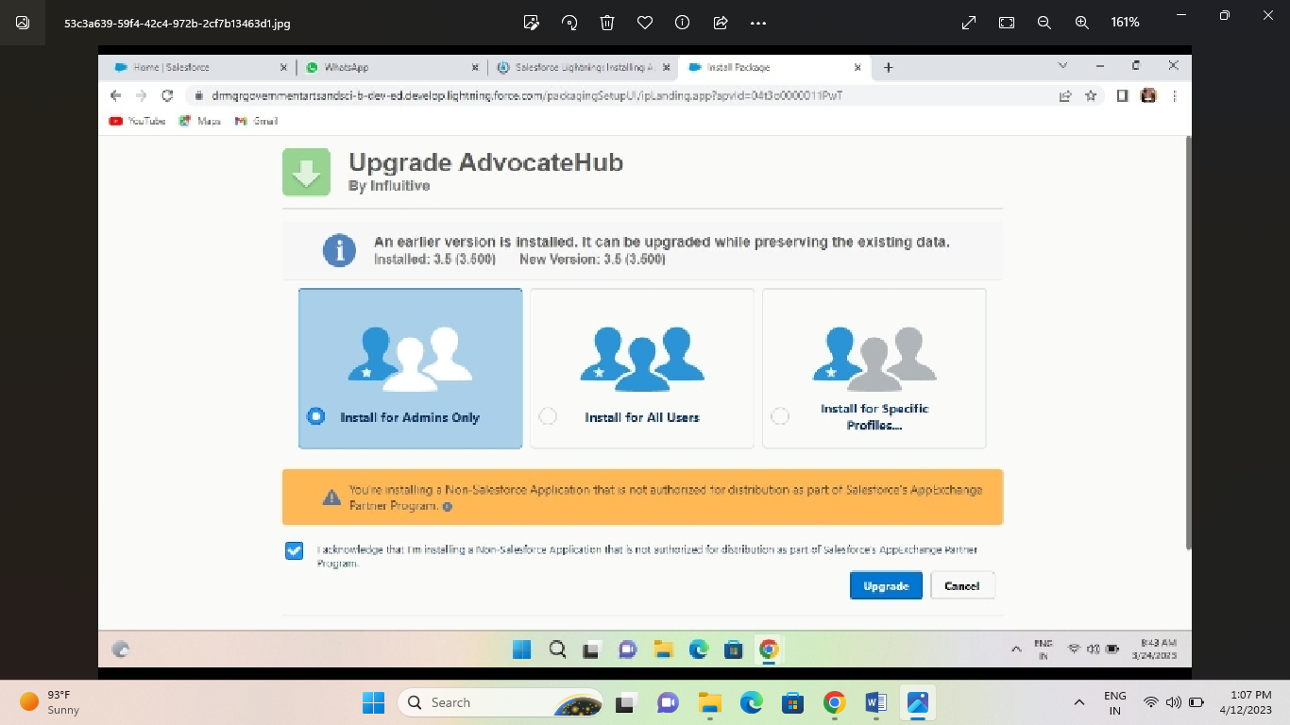

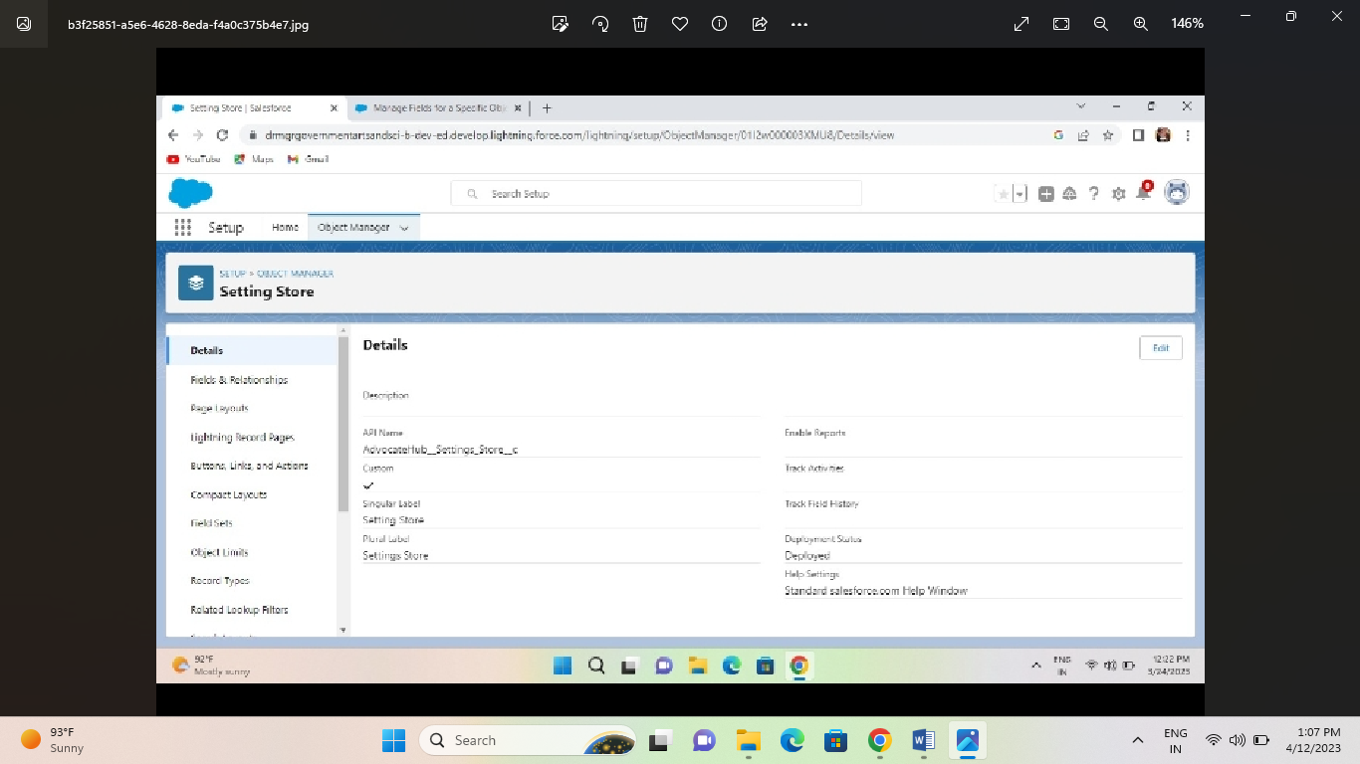

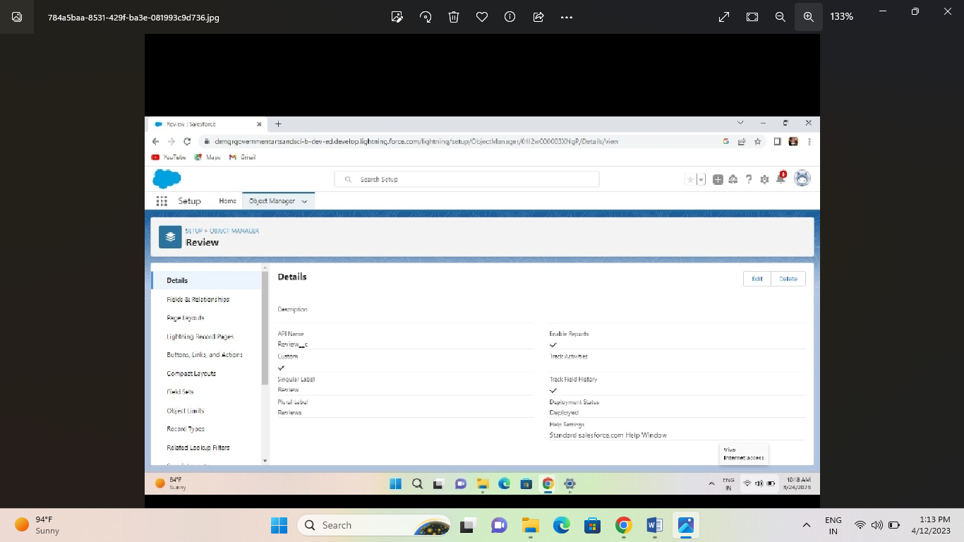

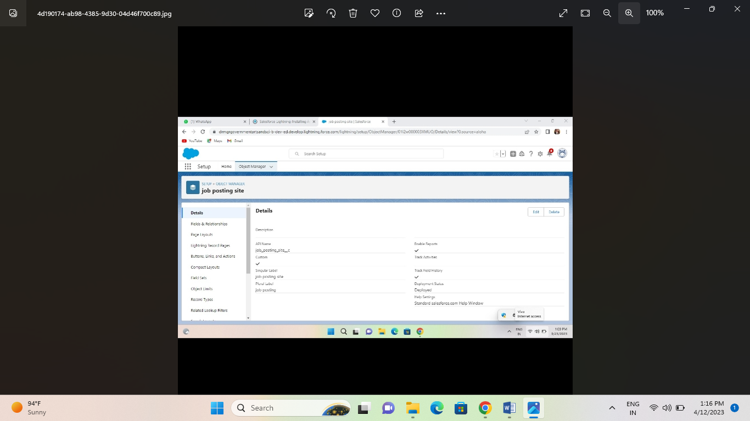

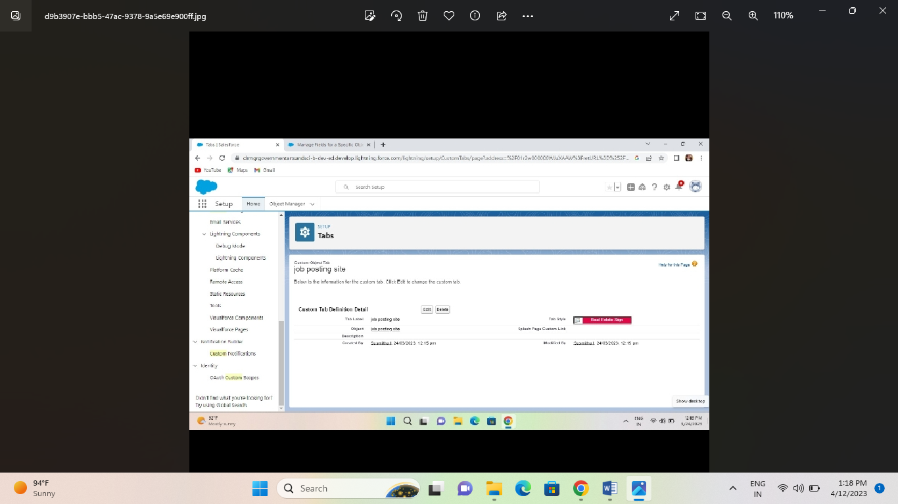

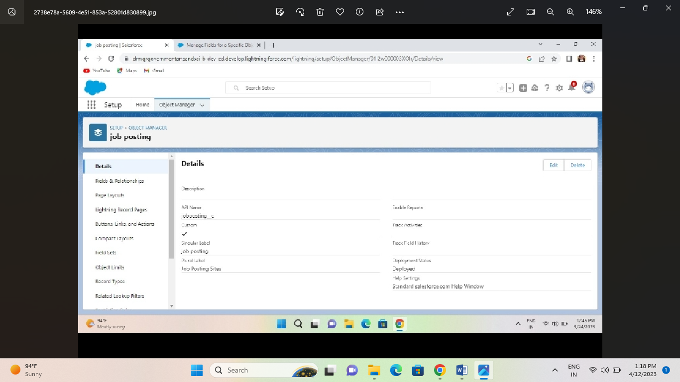

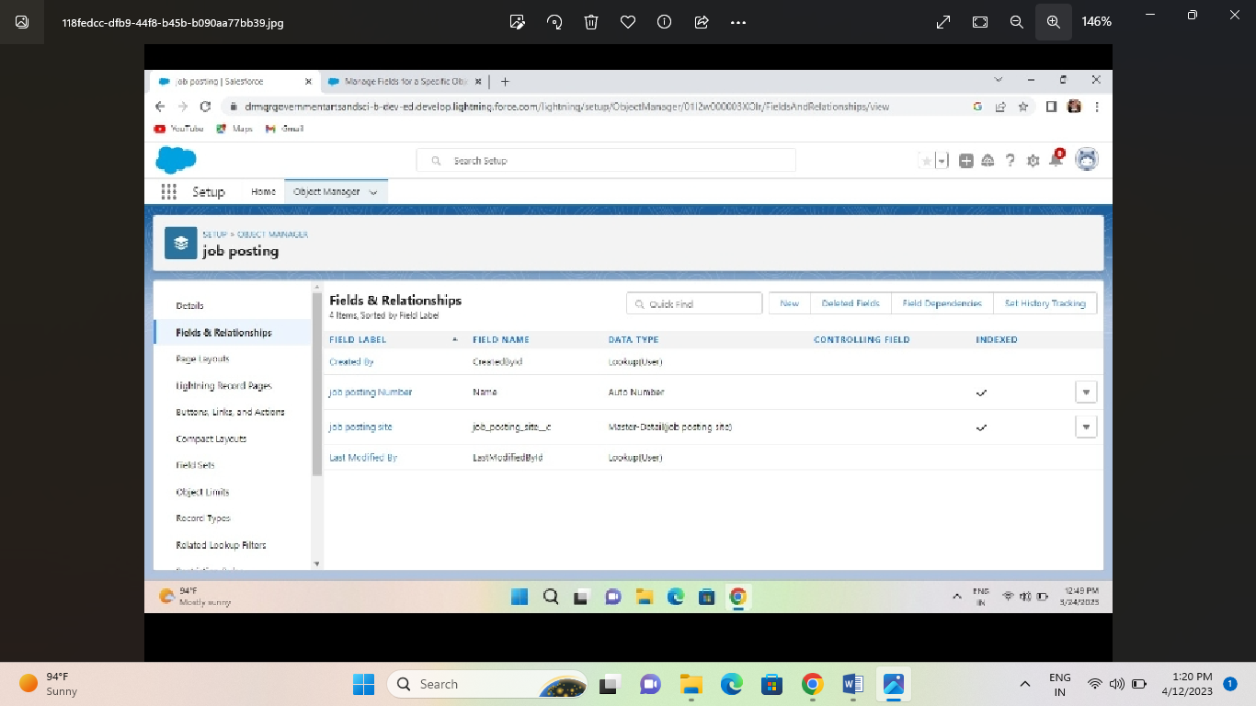

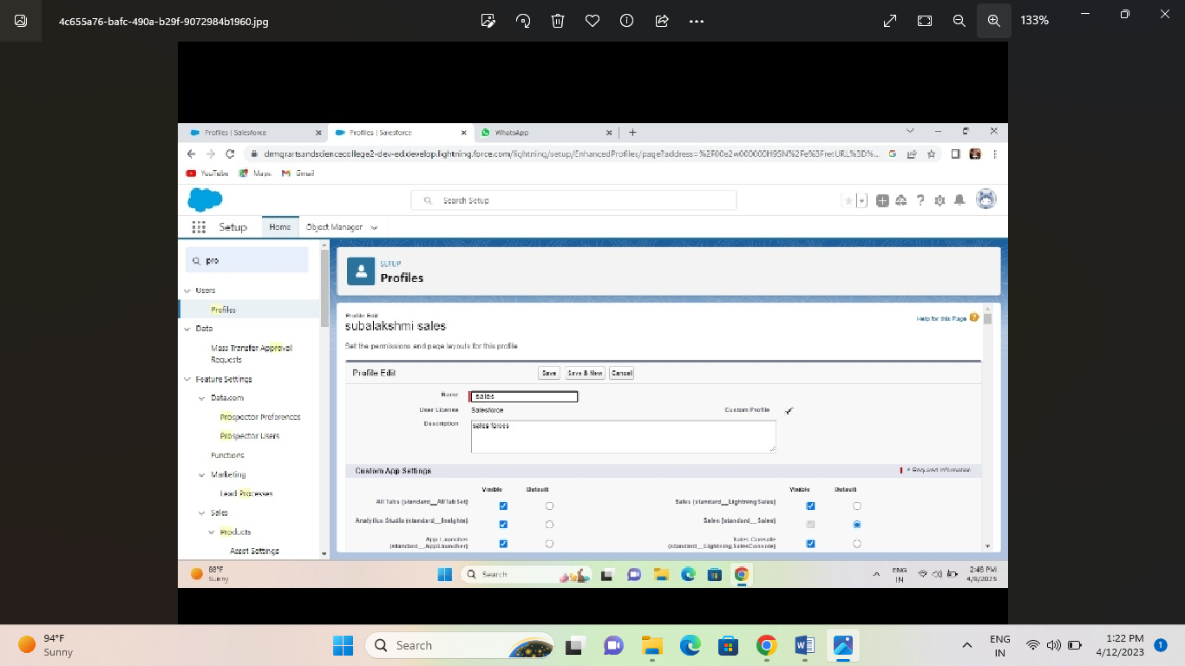

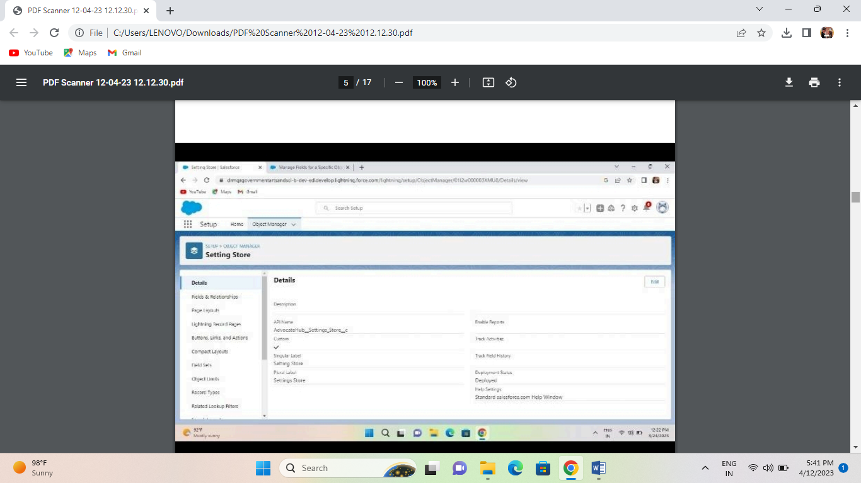

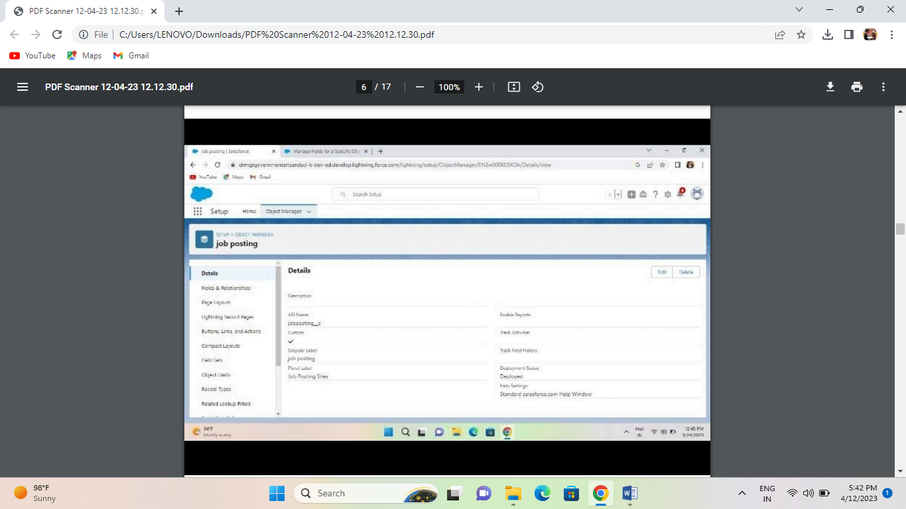

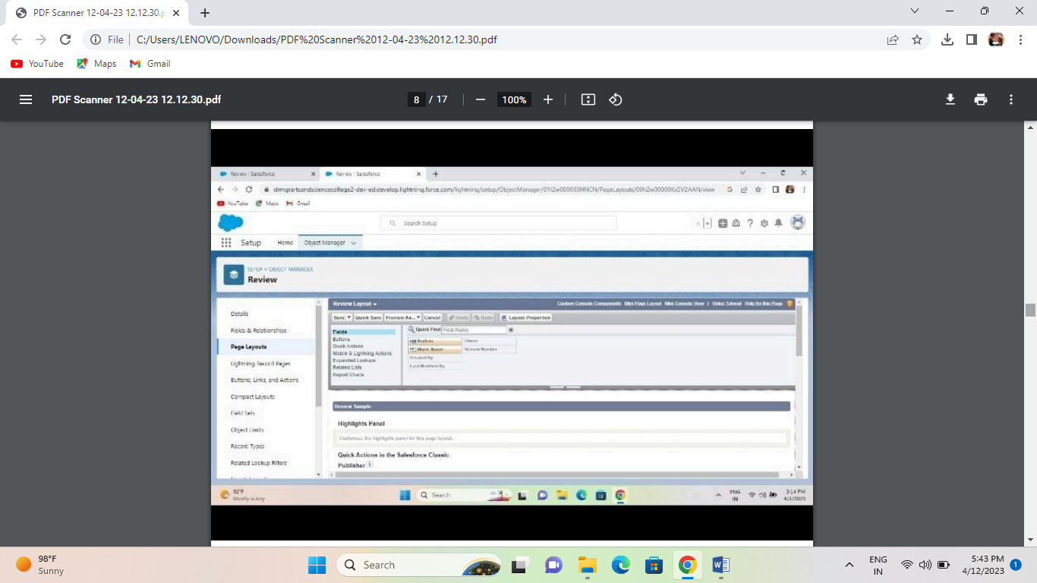

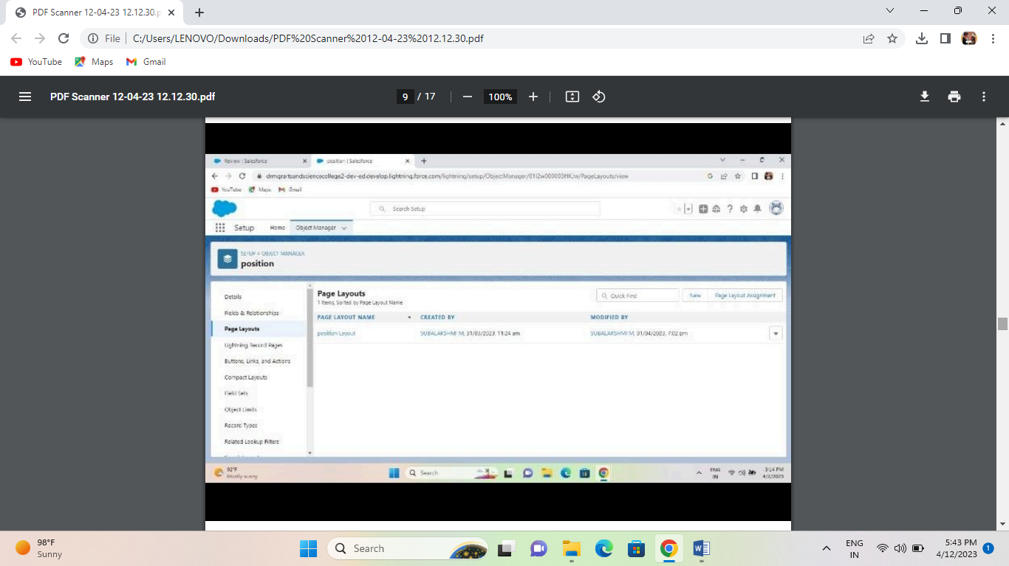

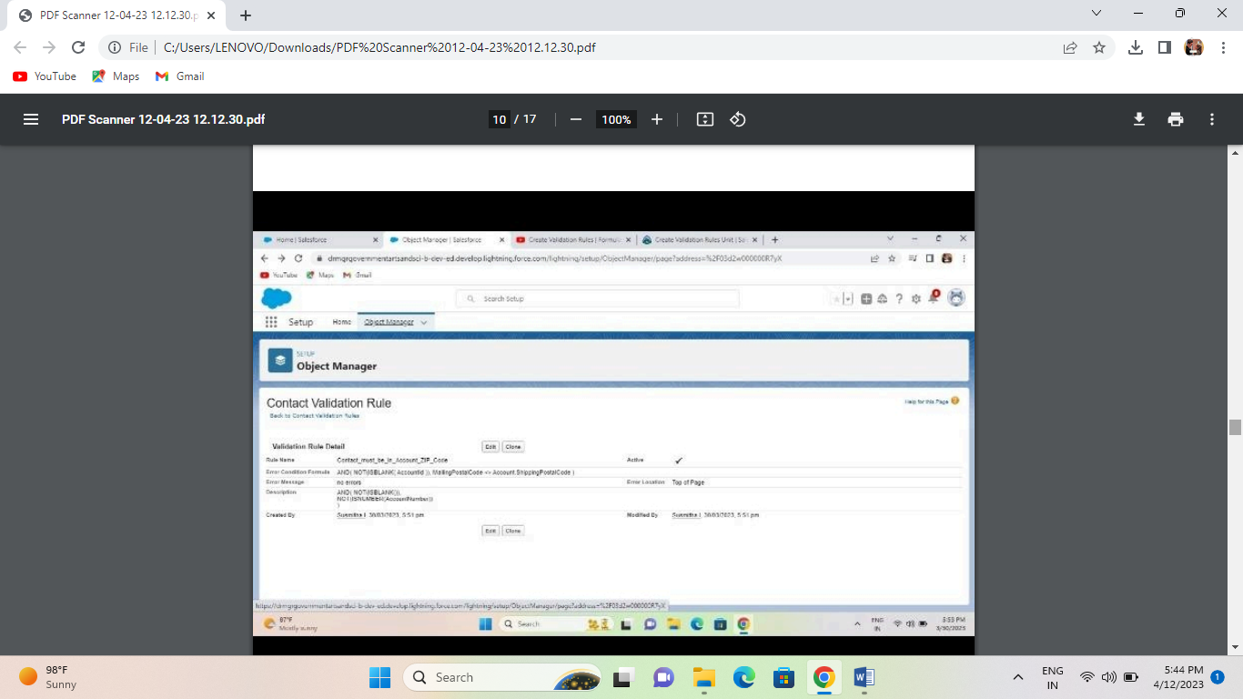

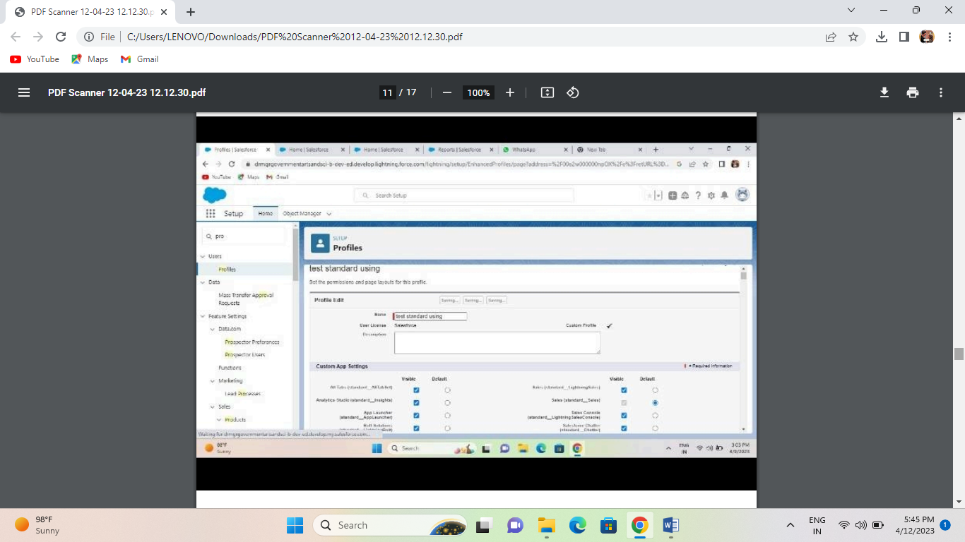

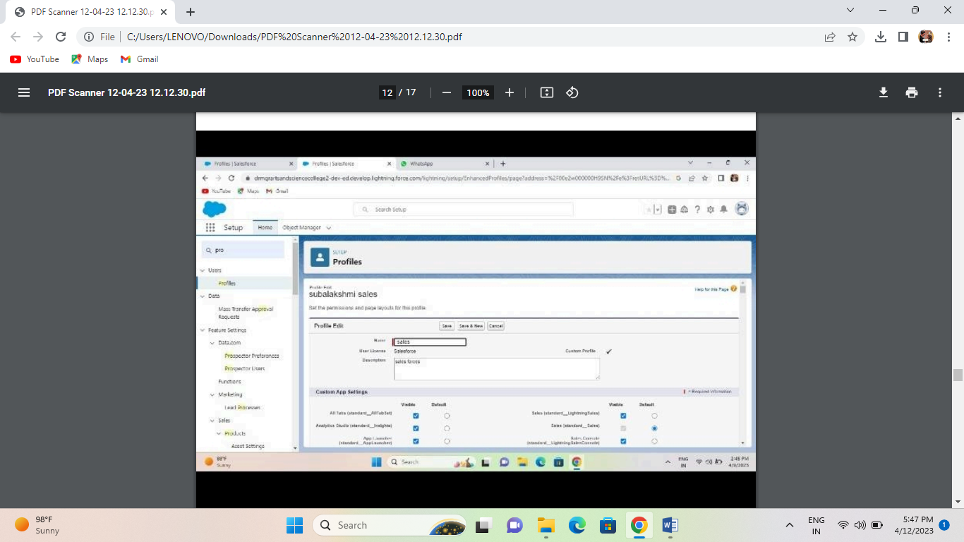

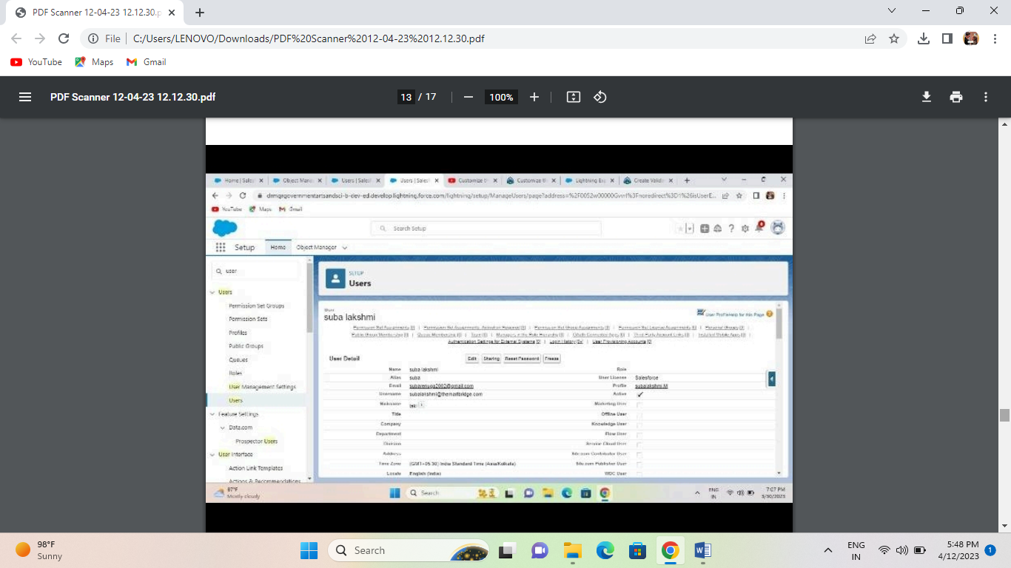

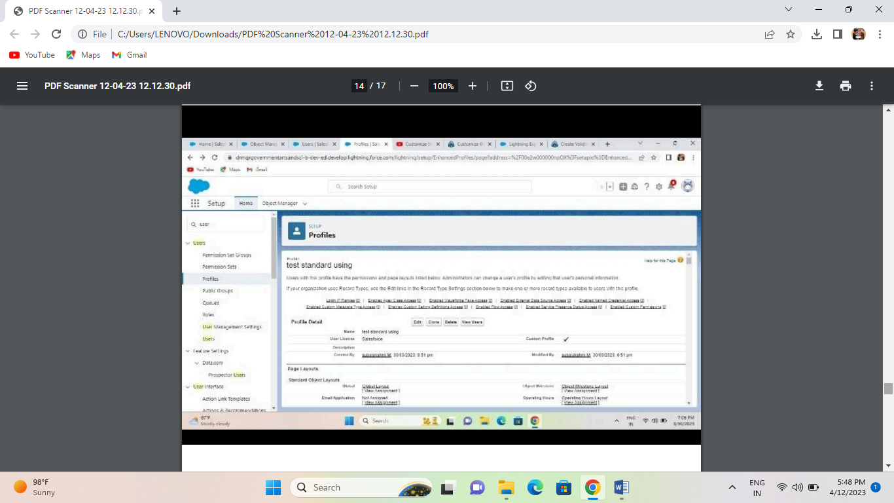

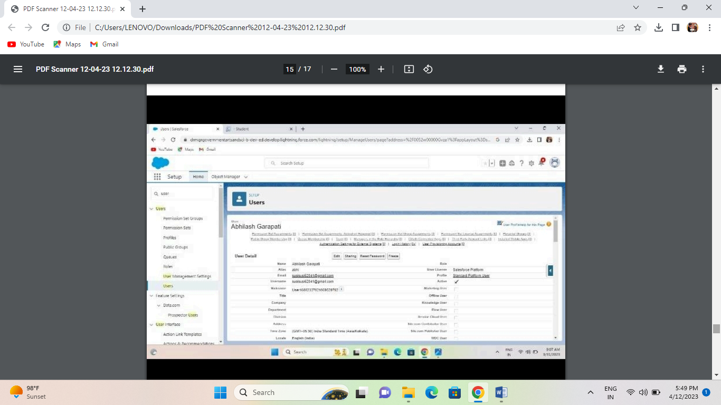

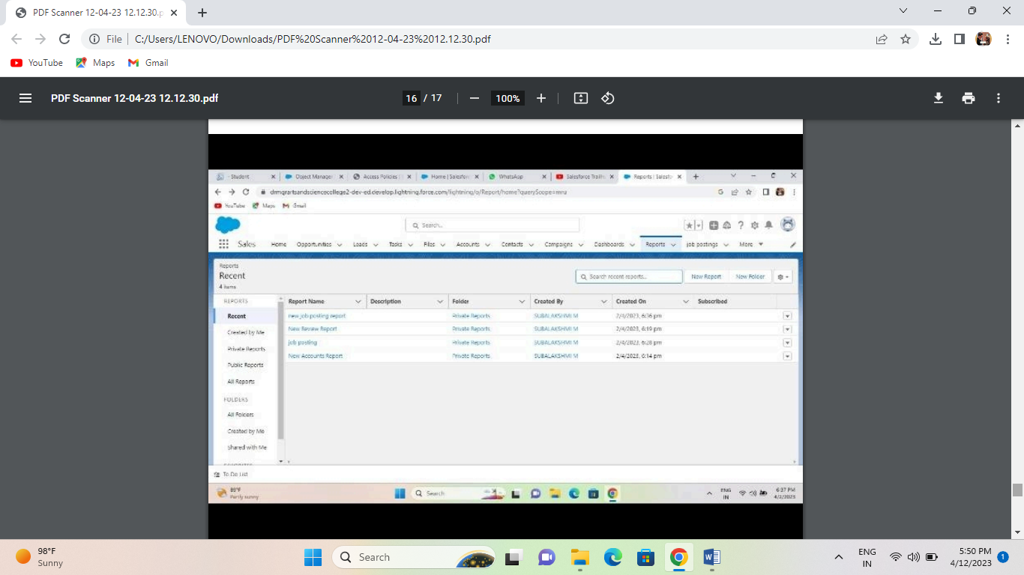

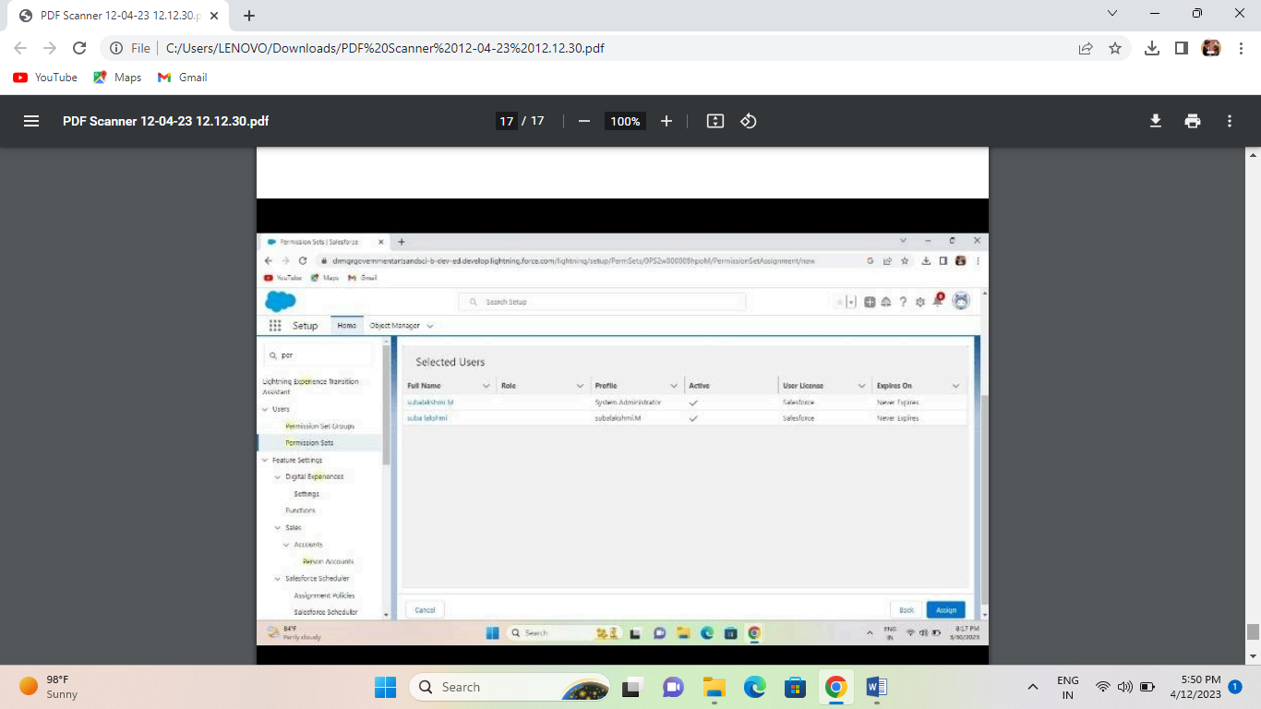

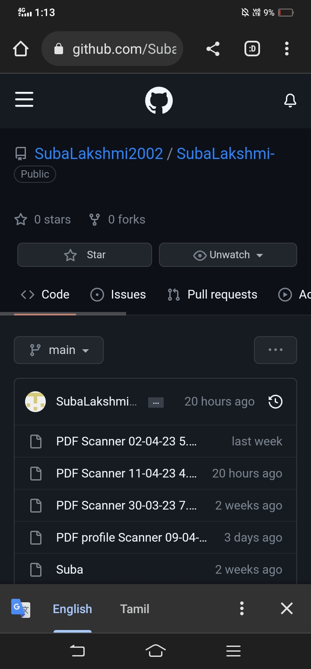

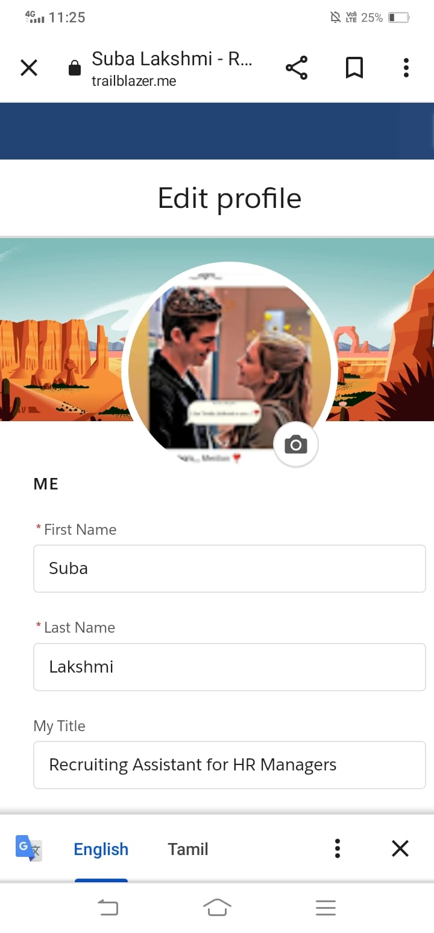

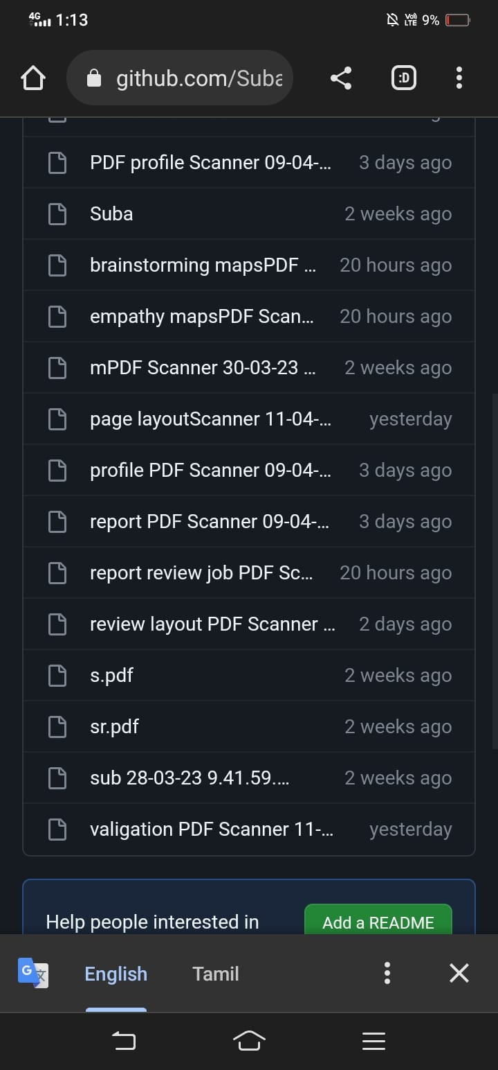

4. TRAIL HEAD PROFILE PUBLIC URL

Team leader- trailblazer.me/id/subalakshmi296

Team member 1-: https://trailblazer.me/id/ssurya252

Team member-2-: https://trailblazer.me/id/ssusi9

Team member3- https://trailblazer.me/id/sugai7

5. ADVANTAGE AND DISADVANTAGE

5.1 ADVANTAGE:

* Store everything together
* Be more efficient and production
* Employee Training and self-services
* Make fewer mistakes
* Simplifies compliance with regulations
  1. DISADVANTAGE
* Maintaining a safe distance
* Higher competition
* Lower recognition value
* Experience expected
* Conflicts of opinion
* Legal liabilities

6. APPLICATION

Features of HRIS applications include an employee self-service portal, payroll, workforce management, recruitment and hiring, benefits administration, and talent management. These capabilities are often delivered through individual modules that form a unified suite of HR tools.

Human Resources manages 5 main duties: talent management, compensation and employee benefits, training and development, compliance, and workplace safety.

7. CONCLUSION

Human resource development is a means to an end. That end is usually acknowledged to be getting better results from the organization, teams and individuals by understanding and managing performance within an agreed framework of planned goals, objectives and standards

8. FUTURE SCOPE

HRM is concerned with all aspects of manpower planning, recruitment, selection, placement, induction, transfer, promotion, demotion, training, layoffs, development, retrenchment, wages and salaries etc.

The Human Resource Officer is responsible for providing support in the various human resource functions, which include recruitment, staffing, training and development, performance monitoring and employee counseling.

Human Resource Management Professionals are termed as the backbone of an organization. There is a huge demand for such professionals in both the public and private sectors. No matter if you're looking at startups or big reputed companies, human resources play a crucial role in the formation of a company's future.